Develop Storage Solution with Azure Storage
(LAB-204-02-01)

Version Control
Document | Develop Storage Solutions with Azure Storage
Owner | Ahmad Majeed Zahoory
Version | 2.1
Last Change | 3rd April 2024
Description of Change | Task steps updated using Eclipse 2024

Lab Duration: 45 minutes

Lab scenario
You are preparing to store binary data in Azure. As a development group, your team has decided to use Java to manage the data from Azure storage programmatically.

Objectives
After you complete this lab, you will be able to:
- Create new container.
- Delete the container.
- List the existing containers.
- List the container contents.
- Upload blobs in the container.
- Get blob from the container.
- Upload blob with metadata in the container.
- Update metadata for the existing blob.
- Create Pre-signed URL.
- Get blob using Pre-signed URL.
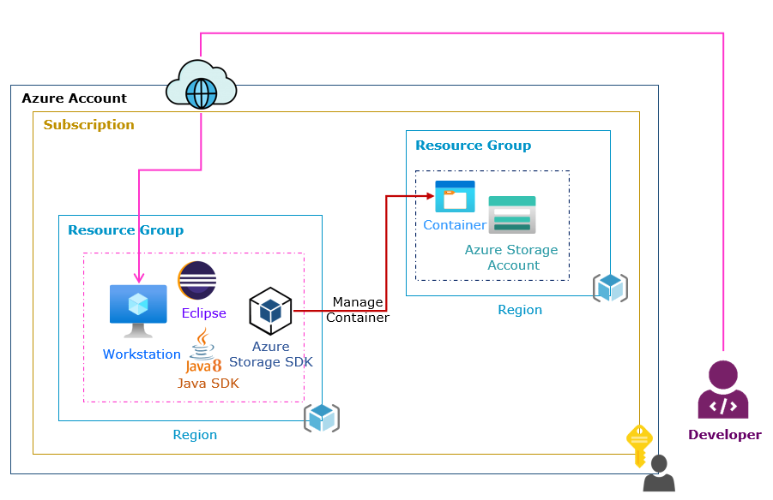

Task 1: Create Workstation
In this task, you will create the virtual machine to build development environment.
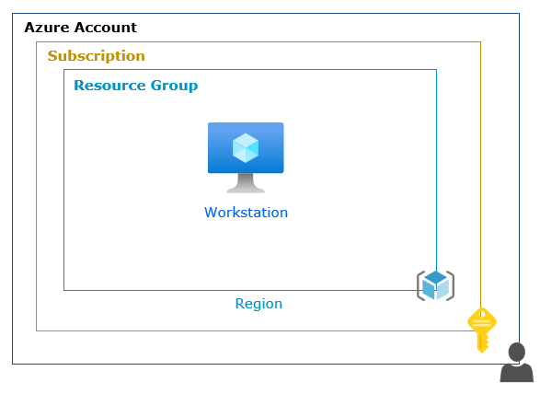
Step 1: Create Azure Virtual Machine
- From the Azure portal, select the Virtual machines.

- Select the Create.

- Select the Azure Virtual Machine.

  - In the Basic page:

- Subscription: Dropdown and select your Default subscription.

- Resource Group: Select Create new:

      - Name: Write az-devec-rg.

      - Select Ok.

- Name: Write dev-ec-ws.

- Region: Dropdown and select West Europe.

- Availability options: Dropdown and select No infrastructure redundancy required.

- Security type: Dropdown and select Standard.

- Image: Select See all images.

        - Microsoft Windows 10: Click on Select.

          - Select Windows 10 Pro, version 22H2 – x64 Gen2.

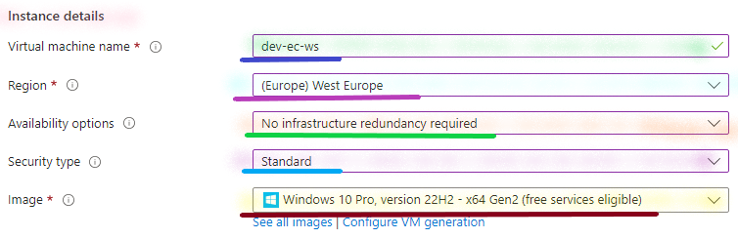
- Size:

- Select See all sizes.

  - In the Search box, type D2as_v5.

  - Select D2as_v5.

    - Click on Select.

- Administrator Account:

    - Username: Write master.

    - Password: Write Lab@password.

    - Confirm password: Write Lab@password.

- Inbound Port Rules:

- Public inbound ports: Select Allow selected ports.

- Select inbound ports:

  - Dropdown and select RDP (3389).

- Licensing: Enable the Checkmark against I confirm I have an eligible Windows 10 license with multi-tenant hosting rights.

- Select the Next: Disks to continue.

  - In the Disks page:

    - Select the Next: Networking to continue.

  - In the Networking page:

    - Select the Next: Management to continue.

  - In the Management page:

    - Select on the Next: Monitoring to continue.

  - In the Monitoring page:

    - Select on the Next: Advanced to continue.

  - In the Advanced page:

    - Select the Next: Tags to continue.

  - In the Tags page:

    - Select the Next: Review + create to continue.

  - In the Review + create page:

    - Select the Create.

Step 2: Enable the Lock
- From the Azure portal, select the Resource groups.
  - Open the az-devec-rg.
      - Select the Locks under Settings.
      - Select Add.

        - From the Add lock page:
          - Lock name: Write Delete-Lock.

          - Lock type: Dropdown and select Delete.

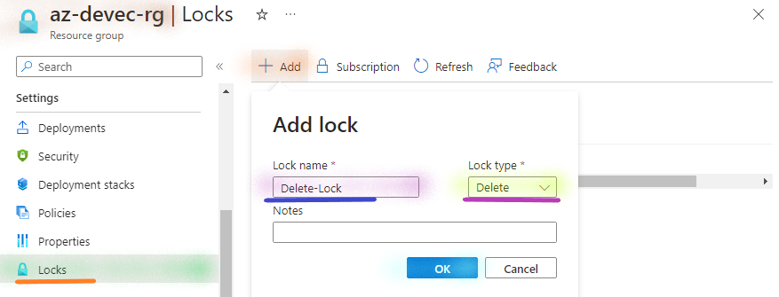
          - Select Ok.

Task 2: Deploy the Java SDK and Eclipse IDE
In this task, you will build development environment and install the Java and Eclipse.
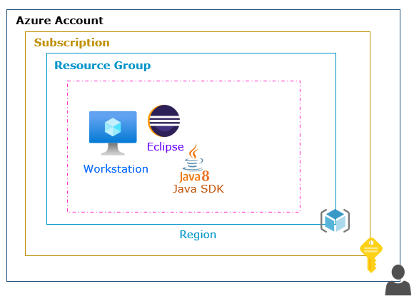
Step 1: Copy the Workstation Public IP Address
- From the Azure portal, select the virtual machines.

  - Open the dev-ec-ws.

    - Copy the Public IP Address in Notepad.
Step 2: Connect to the Workstation
- From your Local Desktop/ Laptop, right click on Start & Run.

  - In the Open, write mstsc.

  - Select Ok.

- From the Remote Desktop Connection:

      - Computer: Write the Public IP Address of the dev-ec-ws.

      - Select Connect.

- Username: Write master.

- Password: Write the Lab@password.

- Select Ok.
Step 3: Install the Java
- From the dev-ec-ws (Windows 10 workstation).

  - Download and install the Java SE Development Kit 8 for Windows x64.

https://bitbucket.org/ahmadzahoory/development/downloads/jdk-8u351-windows-x64.exe

Step 4: Configure the Environment Variable
- From the dev-ec-ws (Windows 10 workstation), right click on Start & Run.

  - In the Open, write C:\Program Files\Java.

  - Select Ok.

    - Open the JDK folder.
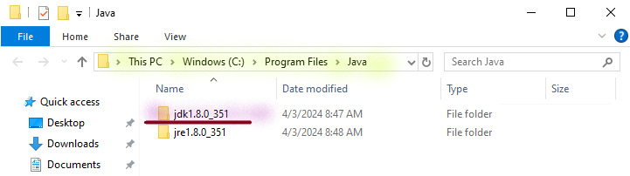
        - Click on the Path section.
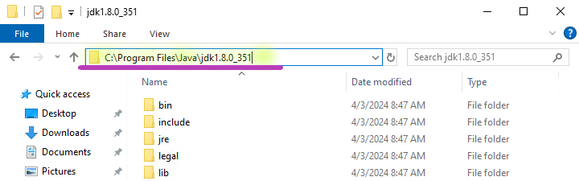
          - Copy the jdk path in Notepad.

- From the dev-ec-ws (Windows 10 workstation), right click on Start & Run.

  - In the Open, write sysdm.cpl.

  - Select Ok.

    - From the System Properties:

      - Select Advance.

      - Select Environment Variables.

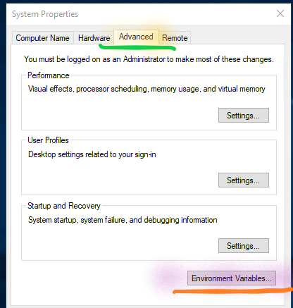

      - Select System variables.

        - Select New.

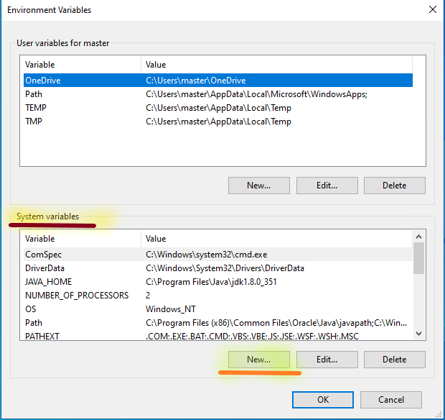
          - Variable name: Write JAVA_HOME.

          - Variable value: Copy the JDK path (which you have copied in the previous step).

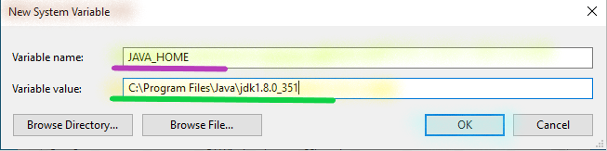
          - Select Ok.

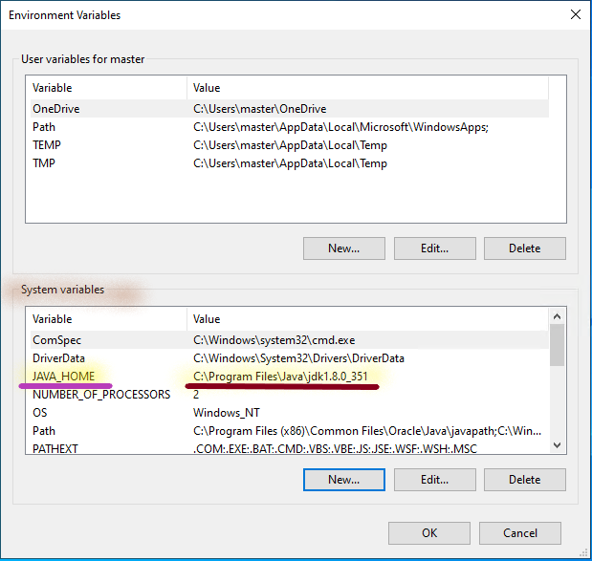

      - Select Ok.

4) Select Ok.

Step 5: Check the Java Version
- From the dev-ec-ws (Windows 10 workstation), right click on Start & Run.

  - In the Open write cmd.

  - Select Ok.

    - From the command line interpreter, write java -version and press Enter.

    - From the command line interpreter, write echo %JAVA_HOME%, and press Enter.

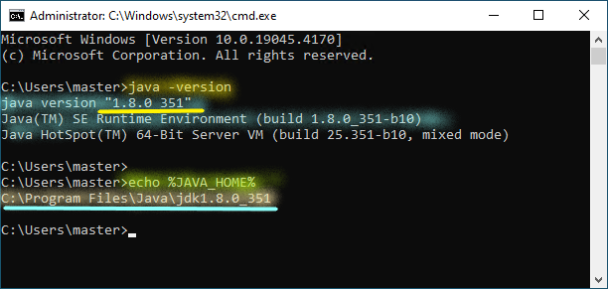
Step 6: Install the Eclipse IDE
- From the dev-ec-ws workstation.

  - Download the Eclipse IDE for Windows x64.

https://bitbucket.org/ahmadzahoory/ide/downloads/eclipse-inst-jre-win64.exe

  - Install the Eclipse IDE for Windows x64.

    - From the Eclipse Installer:

      - Select Eclipse IDE for Java Developers.
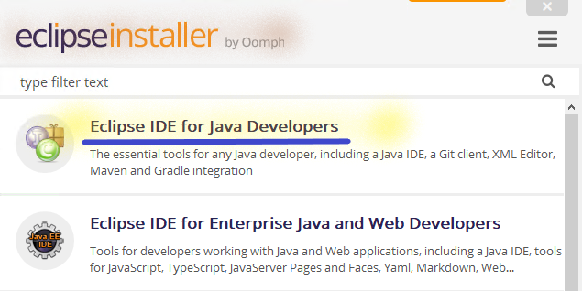

Task 3: Create Azure Storage Accounts
In this task, you will create storage accounts.
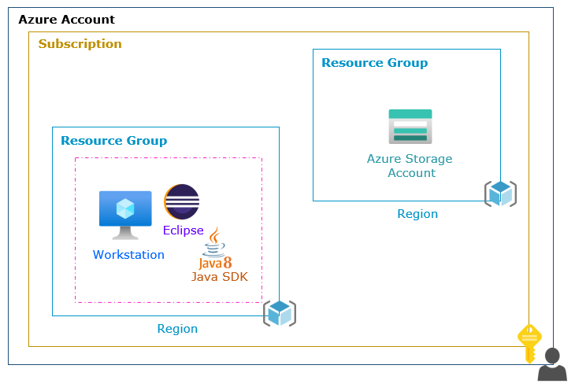
Step 1: Create Azure Storage Account
- From the Azure portal, select the Storage accounts.

- Select Create.

  - In the Basic page:

- Subscription: Dropdown and select your Default subscription.

- Resource group: Select Create new:

      - Name: Write az-stg-rg.

      - Select Ok.

- Storage account name: Write azstorage123.

- Region: Dropdown and select East US.
- Performance: Select Standard.
- Redundancy: Dropdown and select Locally-redundant storage (LRS).

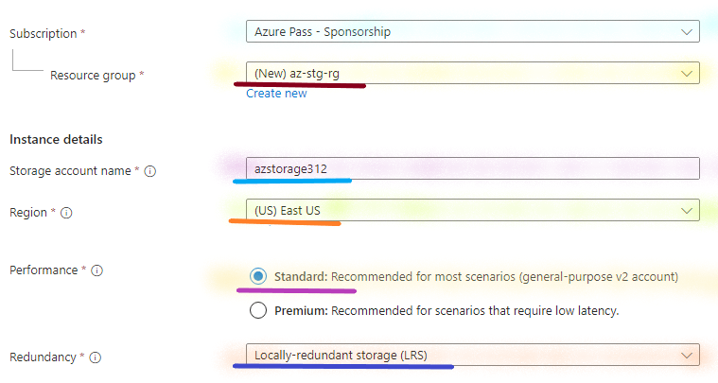
- Select Next.
  - In the Advanced page:

    - Select Next.
  - In the Networking page:

    - Select Next.

  - In the Data Protection page:

    - Select Next.
  - In the Encryption page:

    - Select Next.
  - In the Tags page:

    - Select Next.

  - In the Review + create page:
    - Select Create.

Step 2: Copy the Storage Access Keys
- From the Azure portal, select the Storage accounts.
- Open azstorage123 storage account.
  - Select Access keys under Security + networking.

    - Copy the Storage account name in the Notepad.
    - Key 1:
      - Key: Click on Show.
        - Copy the Key in the Notepad.
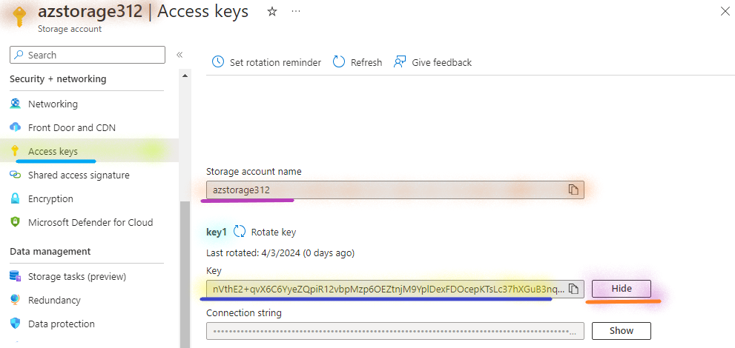

Task 4: Create Maven Project
In this task, you will create a maven (java) project to manage storage programmatically.
Step 1: Review the Java Source Code
- Unzip the storage-code.zip.

Step 2: Copy the Source Code
- Return to the dev-ec-ws workstation.

- From the dev-ec-ws (Windows 10 workstation), right click on Start & Run.

  - In the Open, write C:\.

  - press Ok.

    - Create blob-code folder in C drive.

    - Open the blob-code folder.

      - Copy the Code (Storage code) in the blob-code folder.

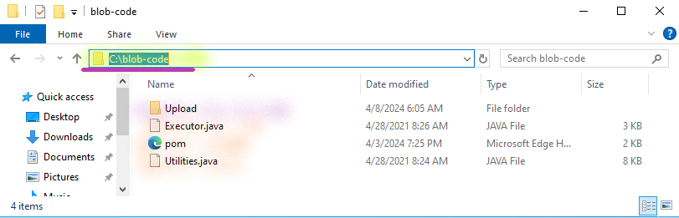
Step 2: Launch the Eclipse IDE
- From the dev-ec-ws (Windows 10 workstation).

- Open the Eclipse IDE for Java Developers.

  - From the Eclipse IDE Launcher page.

    - Workspace: Leave the Default path.

      - Select the Launch.

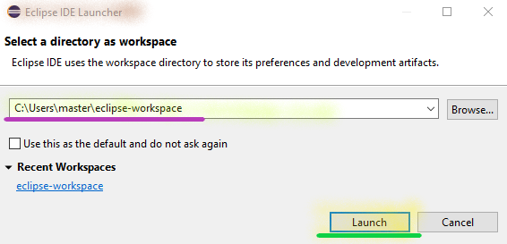
Step 3: Verify the Maven Installation
- From the Eclipse IDE.

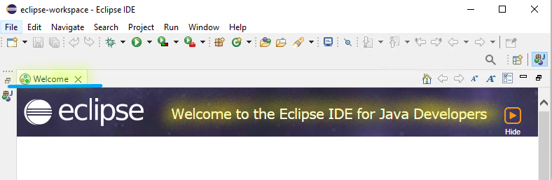
  - Select the Windows.

    - Select the Preferences.
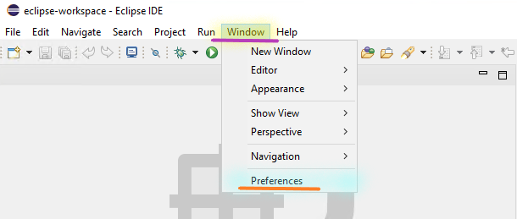
  - From the Preferences page:

    - Expand the Maven.

      - Select Installations.

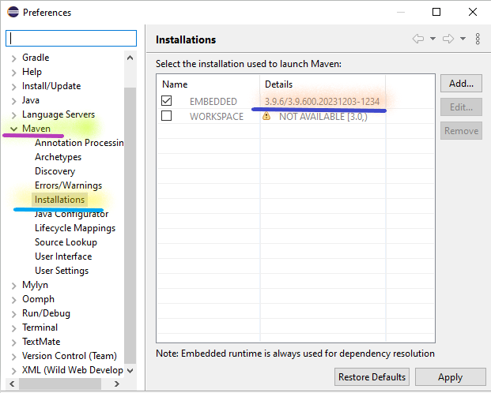
- Click on Cross to close the page.
Step 4: Create the Maven Project
- From the Eclipse IDE.

  - Select File.

    - Select New.

      - Select Project.
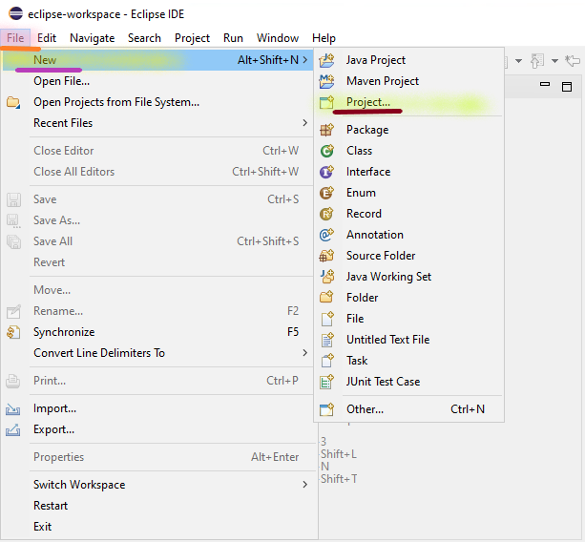
  - From the New Project page:

    - In the Create a Maven project section:

      - Expand the Maven.

        - Select Maven Project.
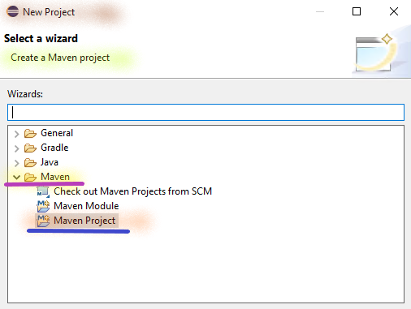

          - Select Next.

  - From the New Maven project page:

    - In the Select project name and location section:

      - Create a simple project: Enable the Checkmark.
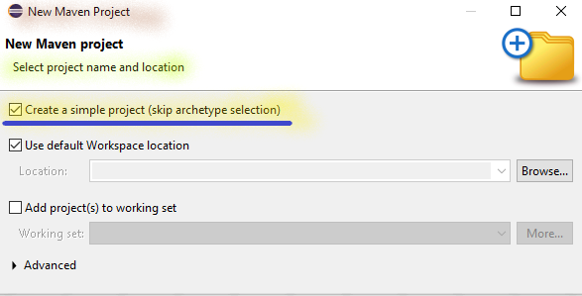

        - Select the Next.

    - In the Enter a group id for the artifact section:

      - Group Id: Write com.azure.storage.

      - Artifact Id: Write azurestglab.
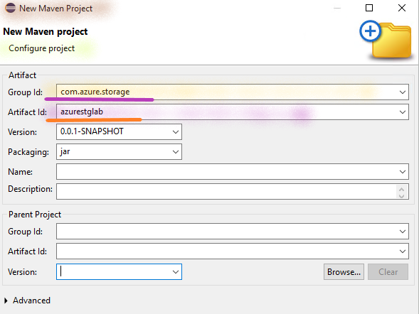

        - Select Finish.

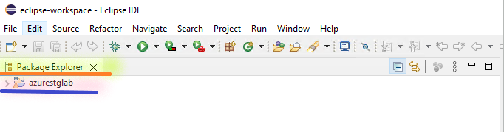

Step 5: Create the Package
- From the Eclipse IDE.

- Expand the azurestglab project.

  - Right-click on the azurestglab project.

    - Select New.

      - Select Package.
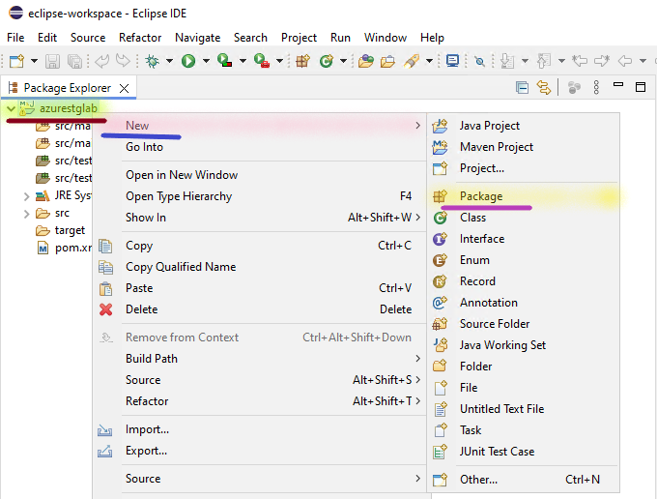
    - From the New Java Package page:

      - In the Create a new Java package section:

        - Name: Write com.azure.storage.
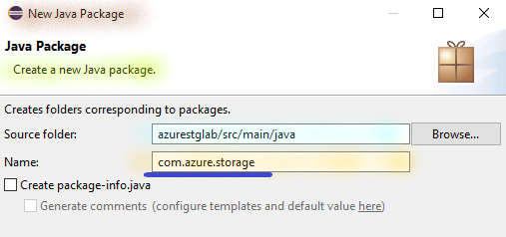

          - Select Finish.

Step 6: Create the File in the Package
- From the Eclipse IDE.

- Expand the azurestglab project.

  - Expand the src/main/java resource path.
Create Executor.java File

    - Right-click on the com.azure.storage package.

      - Select New.

        - Select File.
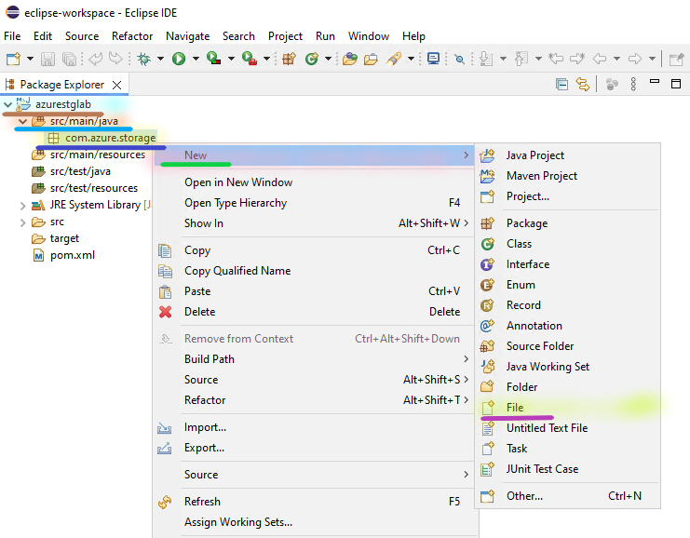
      - From the Create New File page:

        - In the Create a new file resource section:

          - File name: Write Executor.java.

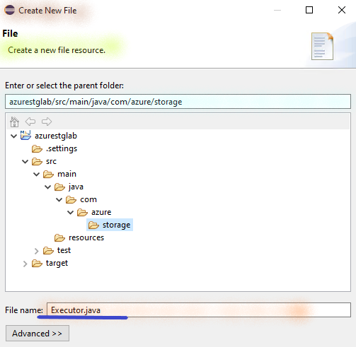
            - Select Finish.
Create Utilities.java File
    - Right-click on the com.azure.storage package.

      - Select New.

        - Select File.

      - From the Create New File page:

        - In the Create a new file resource section:

          - File name: Write Utilities.java.

            - Select Finish.

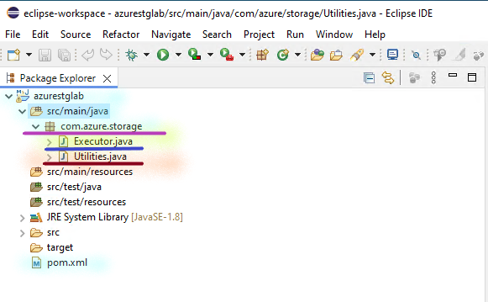
Step 7: Update the Java Code
Copy Executor.java
- From the Eclipse IDE.

- Double-click on the Executor.java.

  - Paste the Code from Executor.java file (copy from C:\blob-code\Executor.java).

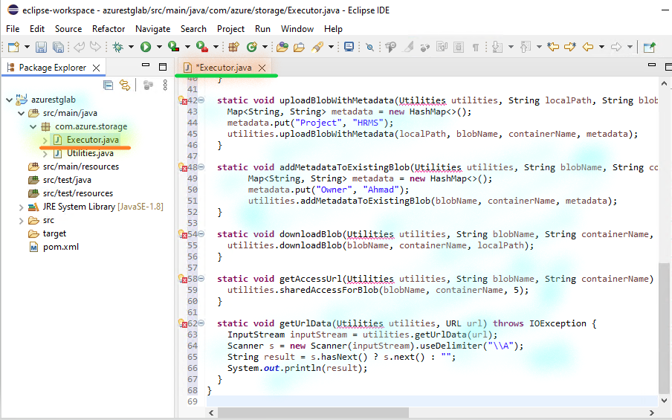

    - Press CTRL + S (to save the file).

Copy Utilities.java
- Double-click on the Utilities.java.

  - Paste the Code from Utilities.java file, (copy from C:\blob-code\Utilities.java).

    - Press CTRL + S.

Copy pom.xml
- Double-click on the pom.xml.

  - Remove the existing code.

  - Copy the code from pom.xml file (copy from C:\blob-code\pom.xml).

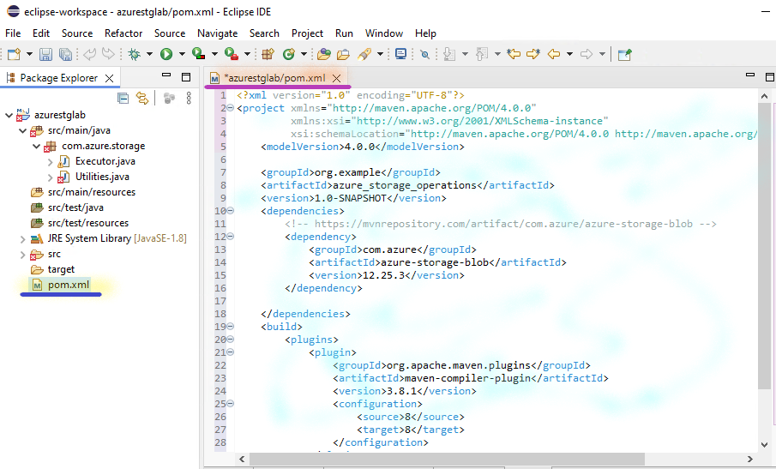

    - Press CTRL + S.

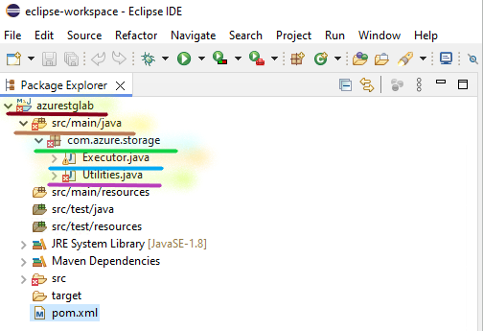
Step 7: Update the Project
- From the Eclipse IDE.

- Right-click on the JRE System Library.

  - Select Properties.
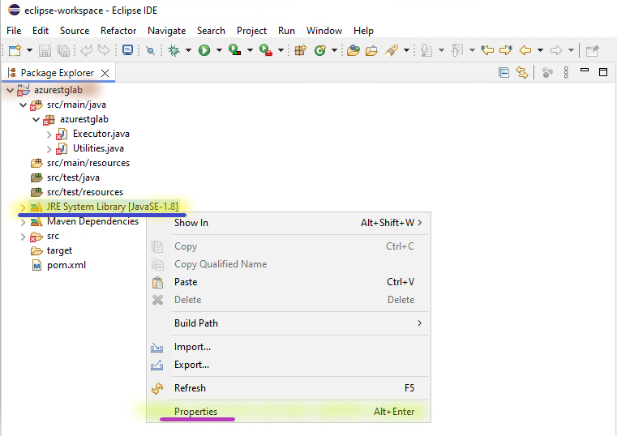
    - From the Properties for JRE System Library page:

      - In the JRE System Library section:

        - Execution environment: Dropdown and select JavaSE-1.8 (jdk).

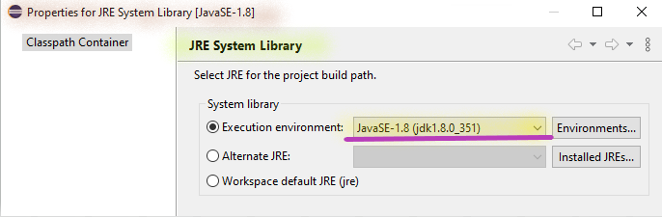

          - Select Apply and Close.

- From the Eclipse IDE.

- Right-click on the azurestglab project.

  - Select Maven.

    - Select Update project.
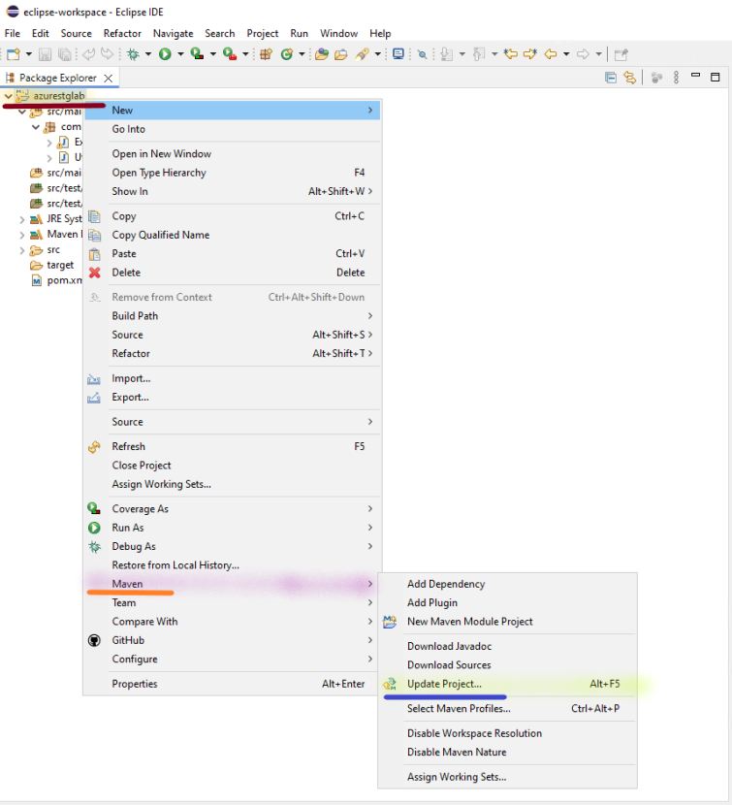
    - From the Update Maven Project page:

      - In the Select Maven projects and update option section:

        - azurestglab: Enable the Checkmark.
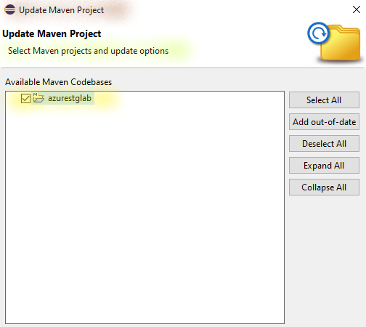

          - Select Ok.

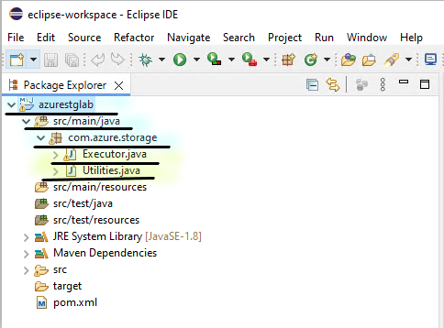

Step 8: Configure Storage Account Credentials
- From the Eclipse IDE.

  - Double-click on the Executor.java.

    - Line number 16: Replace the STORAGE-ACCOUNT-NAME with the storage account name of azstorage123 (which you have copied in the previous step).

    - Line number 17: Replace the STORAGE-ACCOUNT-KEY with the Key 1 of azstorage123 (which you have copied in the previous step).
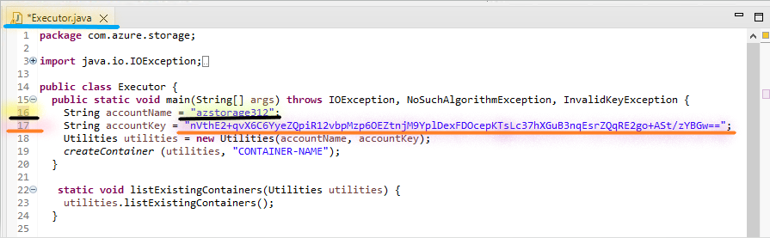
      - Press CTRL + S.

Task 3: Manage Azure Storage from Eclipse
In this task, you will manage Azure Storage from Eclipse using Java.

Step 1: Create New Container
- From the Eclipse IDE.

  - Double-click on the Executor.java.

    - Line number 19: Replace the CONTAINER_NAME with the demo container name you want to create.

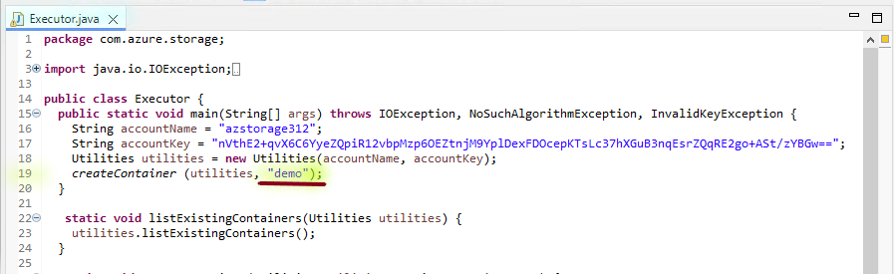
      - Press CTRL + S.

- From the Eclipse IDE.

  - Execute the Run Executor.
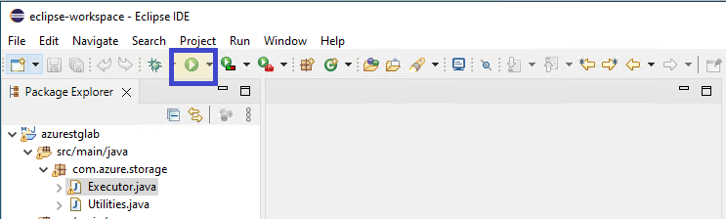

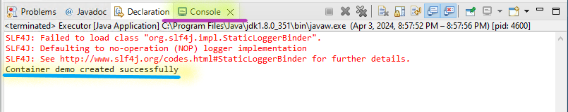

Step 2: Create New (Second) Container
- From the Eclipse IDE.

  - Double-click on the Executor.java.

    - Line number 19: Replace the demo with the images, container name.

      - Press CTRL + S.

- From the Eclipse IDE.

  - Execute the Run Executor.

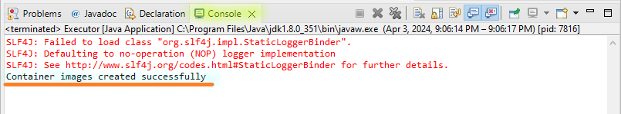
Step 3: List the Containers
- From the Eclipse IDE.

  - Double-click on the Executor.java.

    - Line number 19: Replace the createContainer (utility, "CONTAINER-NAME") method with the listExistingContainers (utilities) method.

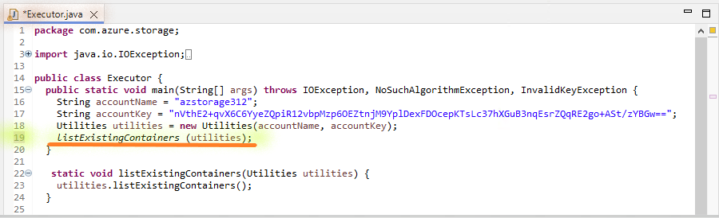
      - Press CTRL + S.

- From the Eclipse IDE.

  - Execute the Run Executor.

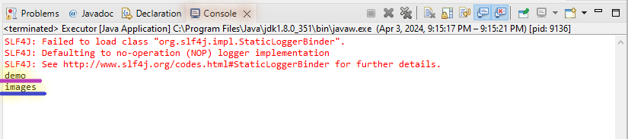

Step 4: View Containers from Storage Account
- From the Azure portal, select the Storage accounts.
- Open azstorage123 storage account.
  - Select Containers under Manage.

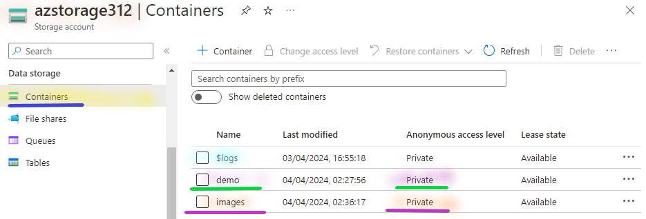

Step 5: Delete the Container
- Return to the dev-ecs-ws Instance.

- From the Eclipse IDE.

  - Double-click on the Executor.java.

    - Line number 19: Replace the listExistingContainers (utilities) method with the deleteContainer (utilities, "demo") method.

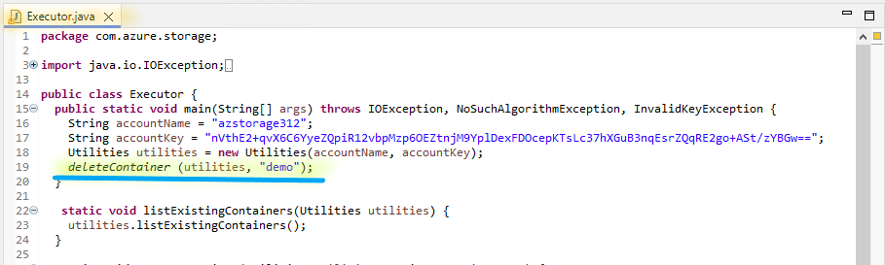
      - Press CTRL + S.

- From the Eclipse IDE.

  - Execute the Run Executor.

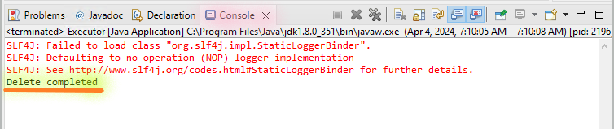
Step 6: List the Containers
- From the Eclipse IDE.

  - Double-click on the Executor.java.

    - Line number 19: Replace the deleteContainer (utilities, "demo") method with the listExistingContainers (utilities) method.

      - Press CTRL + S.

- From the Eclipse IDE.

  - Execute the Run Executor.

Step 7: Upload the Blob
- From the Eclipse IDE.

  - Double-click on the Executor.java.

    - Line number 19: Replace the listExistingContainers (utilities) method with the uploadBlob (utilities, "C:/blob-code/Upload/File01.txt", "File01.txt", "images") method.

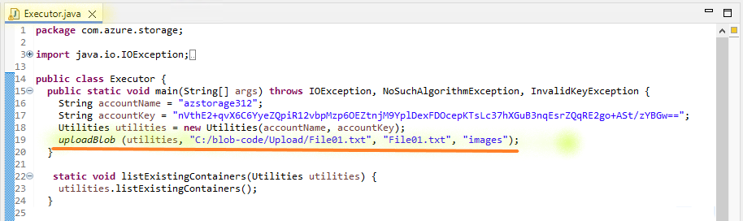

      - Press CTRL + S.

- From the Eclipse IDE.

  - Execute the Run Executor.

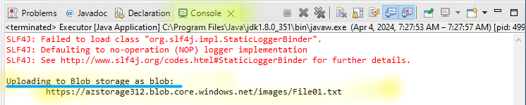
Step 8: List the Blobs
- From the Eclipse IDE.

  - Double-click on the Executor.java.

    - Line number 19: Replace the uploadBlob (utilities, "C:/blob-code/Upload/File01.txt", "File01.txt", "images") method with the listExistingBlobs (utilities, "images") method.

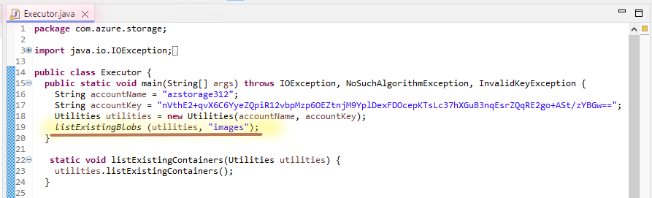

      - Press CTRL + S.

- From the Eclipse IDE.

  - Execute the Run Executor.

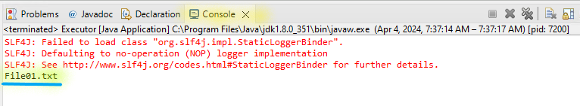
Step 9: Download the Blobs
- From the Eclipse IDE.

  - Double-click on the Executor.java.

    - Line number 19: Replace the listExistingBlobs (utilities, "images") method with the downloadBlob (utilities, "File01.txt", "images", "C:\\blob-code\\File01.txt") method.

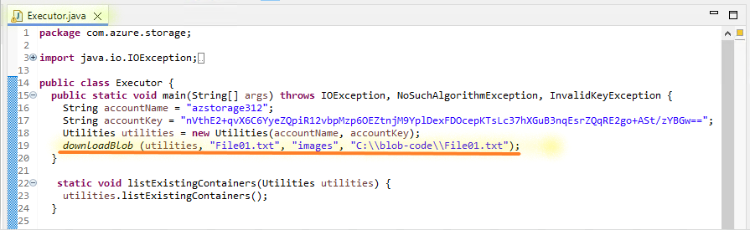
      - Press CTRL + S.

- From the Eclipse IDE.

  - Execute the Run Executor.

Step 10: Read the Blobs
- From the dev-ec-ws (Windows 10 workstation), right click on Start & Run.

  - In the Open, write C:\.

  - press Ok.

    - Open the blob-code folder.

      - Open the File01.txt file in the Notepad.
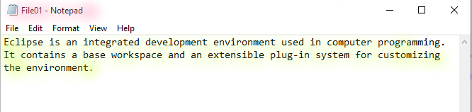

Step 11: Read the Blobs from Storage Account
- From the Azure portal, select the Storage accounts.
- Open azstorage123 storage account.
  - Select Containers under Manage.
    - Open images container.

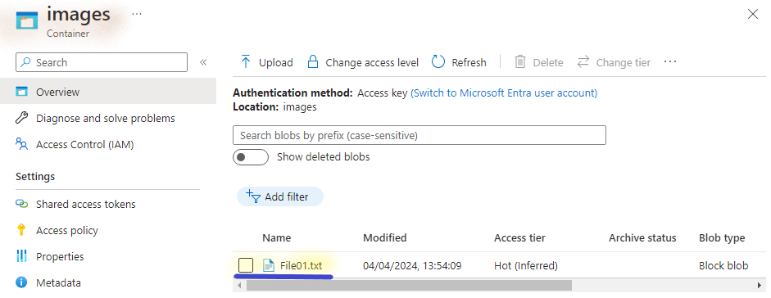
      - Open the File01.txt.

        - Copy the URL in the Notepad.
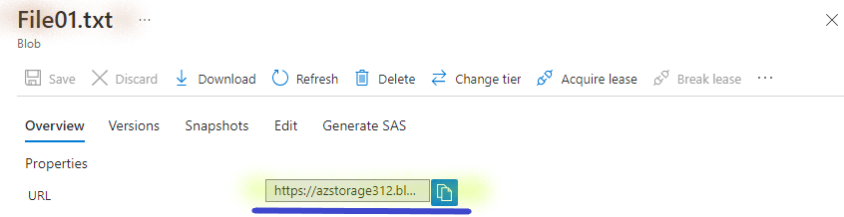

- From the Local Desktop/ Laptop Browser, Copy the URL of File01.txt, to access the Object content.

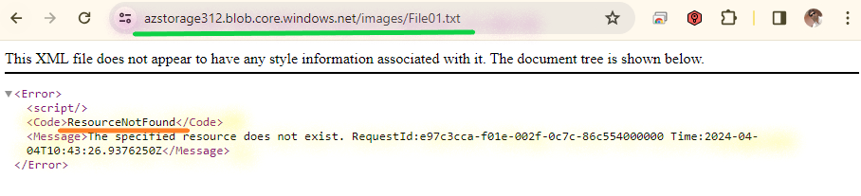

Step 12: Upload the Blob with Metadata
- Return to the dev-ecs-ws Instance.

- From the Eclipse IDE.

  - Double-click on the Executor.java.

    - Line number 19: Replace the downloadBlob (utilities, "File01.txt", "images", "C:\\blob-code\\File01.txt") method with the uploadBlobWithMetadata (utilities, "C:/Blob-Code/Upload/File02.txt", "File02.txt", "images") method.

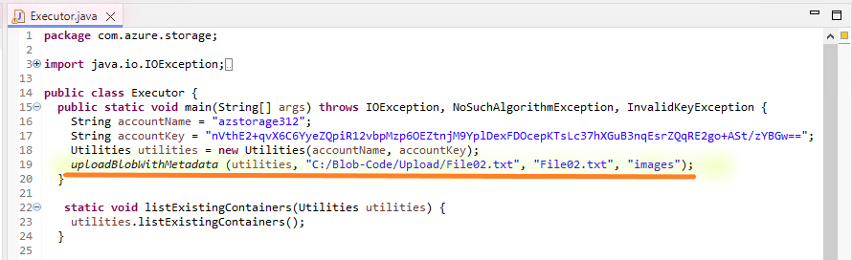
      - Press CTRL + S.

- From the Eclipse IDE.

  - Execute the Run Executor.

Step 13: Update the Blob with Metadata
- From the Eclipse IDE.

  - Double-click on the Executor.java.

    - Line number 19: Replace the uploadBlobWithMetadata (utilities, "C:/Blob-Code/Upload/File02.txt", "File02.txt", "images") method with the addMetadataToExistingBlob (utilities, "File01.txt", "images") method.

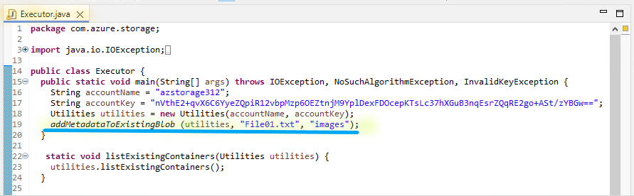
      - Press CTRL + S.

- From the Eclipse IDE.

  - Execute the Run Executor.

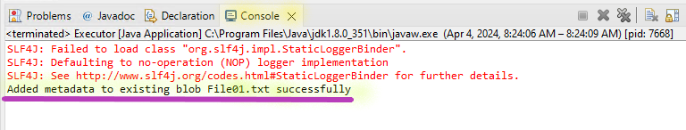

Step 14: Create SAS URL
- From the Eclipse IDE.

  - Double-click on the Executor.java.

    - Line number 19: Replace the addMetadataToExistingBlob (utilities, "File01.txt", "images") method with the getAccessUrl (utilities, "File02.txt", "images") method.

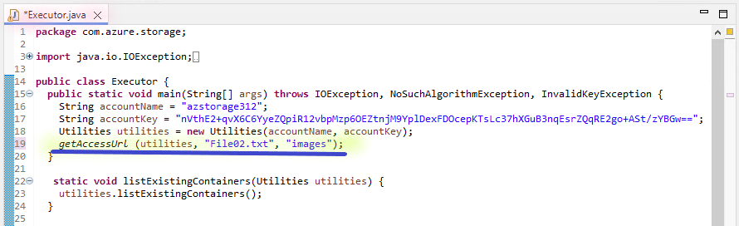
      - Press CTRL + S.

- From the Eclipse IDE.

  - Execute the Run Executor.

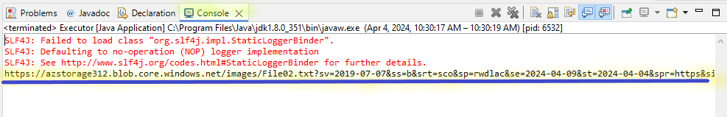
    - Copy the SAS URL in the Notepad.

Step 15: Access the Object from Browser
- From the Local Desktop/ Laptop Browser, Copy the SAS-URL of File02.txt, to access the Object content.

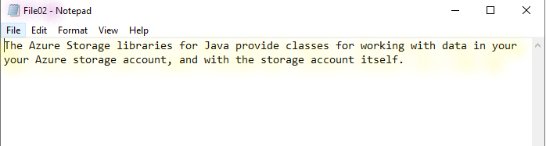
Step 15: Read the Metadata of First Object
- From the Azure portal, select the Storage accounts.
- Open azstorage123 storage account.
  - Select Containers under Manage.
    - Open images container.
      - Open the File01.txt blob.

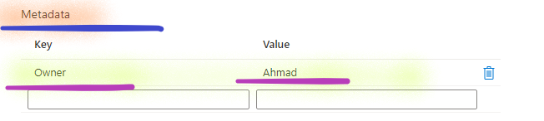
        - Click on Cross to close the page.

Step 16: Read the Metadata of Second Object
- From the Images container.
  - Open the File01.txt blob.

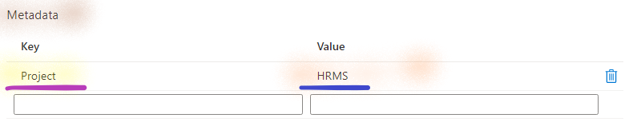
    - Click on Cross to close the page.

Task 4: Stop the Environment
Step 1: Close the Maven Project
- Return to the dev-ecs-ws instance.

- From the Eclipse IDE.

  - Select the azurestglab project.

    - Select the Project.

      - Select the Close Project.

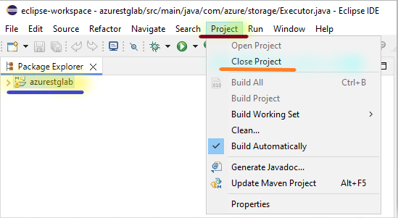
- From the Eclipse IDE.

  - Select the File.

    - Select the Exit.

Step 2: Stop the Workstation
- From the Azure portal, select the virtual machines.

  - Open the dev-ec-ws.

    - Select Stop.
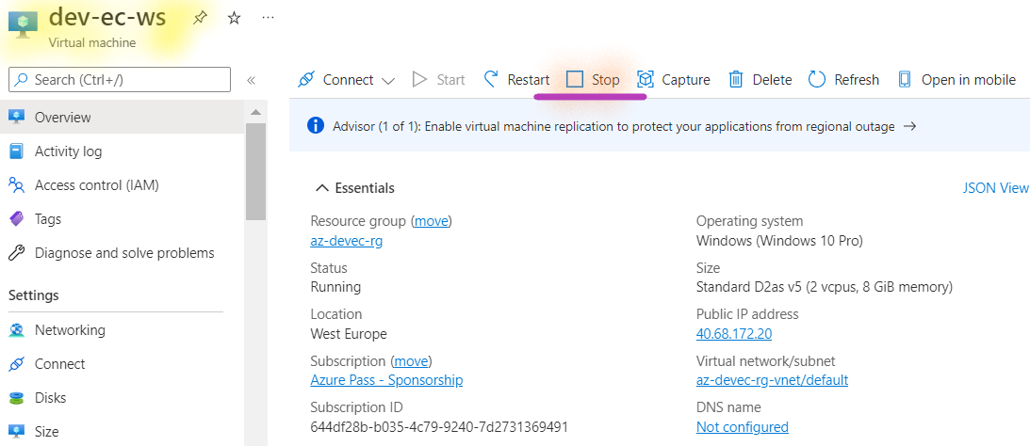
      - Select Yes.

